Base of Hamate as a reconstruction for proximal pole scaphoid fractures
Abstract:
Background: Scaphoid fracture nonunion is a troublesome complication that if untreated will led to avascular necrosis of proximal pole then carpal collapse and degenerative arthritis . The proximal pole of the scaphoid vascular status is an important factor in determining the type of bone graft used whether vascularized or non-vascularized .
The purpose of this study was to evaluate the results of a new technique in the reconstruction of proximal pole scaphoid fractures nonunion with avascular necrosis by using proximal Hamate as an autograft to restore the shape of scaphoid and scapholunate mechanics and the effect of graft size on wrist mechanics.
Patients and methods : This was an interrupted time series clinical trial (quasi experimental) study, that included twenty patients with non-united proximal scaphoid fractures with avascular necrosis of the proximal part treated with excision of the proximal pole of scaphoid and reconstruct with the proximal pole of Hamate and repair scapho-lunate ligament.
Results: All fractures united except two fractures , with a mean period of 10.2 weeks , a mean follow up period was 11 months , there was an improvement in VAS score from 8 (7-9) preoperative to 2 (0-5) post-operative and final Mayo wrist score was 93.1(range 79-98).
Conclusion: The use of proximal hamate as an autograft to reconstruct the proximal osteocartilaginous surface of the scaphoid nonunited fractures with AVN of the proximal pole is a promising technique.
Key words: Scaphoid nonunion , Avascular necrosis (AVN) , Capito-hamate ligament (CH) , Triquetro-hamate ligament ( TH).

Introduction:
Proximal pole scaphoid fractures usually present with mild to moderate radial-sided wrist pain . Due to the mildness in complaints and difficulty in visualizing the fracture line in x-rays, the diagnosis may have been missed at the time of injury , and led to fracture nonunion at the time of detection .[1]
Nonunion of proximal pole scaphoid fractures have a lot of difficulties to reconstruct due to poor blood supply, the need to reconstruct the scapholunate ligament and fragmentation. [2]
The proximal pole vascular status is an important factor in decision making when treating proximal pole fracture nonunion , so accurate preoperative vascular status assessment is important. [3]
A lot of studies reported that unenhanced MRI was accurate for detecting proximal pole scaphoid avascular necrosis in patients with fracture nonunions [3]. Cerezal et al. divided the patients into four groups based on the T1-weighted and T2-weighted fat-suppressed imaging appearance . Group 1 had a signal in the proximal pole isointense to normal carpal bones on T1 images and T2 images (normal-to-minimal ischemia). Group 2 had a slightly low signal in the proximal pole on T1 images and homogeneously increased signals on T2 images (moderate ischemia). Group 3 had variably low signals on T1 images and heterogeneous signals on T2 images (severe ischemia). Group 4 had a low signal on T1-weighted and homogeneously decreased signal on T2 images ( AVN ). [4]
The purpose of this study was to evaluate the results of a new technique in reconstruction of proximal pole scaphoid fractures nonunion with avascular necrosis by using proximal Hamate as an auto graft to restore the shape of scaphoid and scapholunate mechanics and the effect of graft size on wrist mechanics.
Patients and methods:
This was an interrupted time series clinical trial (quasi experimental) study, that included twenty patients with non-united proximal scaphoid fractures with avascular necrosis of the proximal part , who attended Benha University hospital between January 2021 and July 2022 , after approval of the Research Ethics Committee at Faculty of Medicine, University (REC-FOMBU).
Skeletally mature patients with non-united proximal pole scaphoid fracture with avascular necrosis of the proximal part were included in this study. Exclusion criteria included patients with systemic disorders (e.g. anemia, coagulation disorders, diabetes or rheumatoid arthritis), local wrist conditions ( arthritis, previous trauma or surgery, nerve entrapment, infection or malignancy), cervical spine pathology, psychiatric disorder or pregnancy.
The diagnosis was made by full clinical examination and radiological assessment ( x-rays , CT scan and MRI ) for all patients . Avascular necrosis was assessed according to Cerezal et al. [4] MRI classification system , and Grade 4 patients were included in this study (had low signal on T1-weighted and homogeneously decreased signal on T2-weighted fat-suppressed images).
Informed consent was obtained from all patients after giving detailed information about the study. All patients have painful wrist motion that affects their daily activity and functional tasks, the pain is assessed according to the visual analog scale pain score (VAS). The preoperative average VAS score was 8 (range 6-10) , The grip strength was assessed by using a hand-held dynamometer , The grip average was 53.7 % of the sound side (range 48–65 %) .
Surgical technique:
After regional or general anesthesia , the patient is placed supine on the operative table with the upper limb extended on a board with an upper arm tourniquet . A dorsal approach of the wrist is used via dorsal longitudinal wrist incision then the third extensor compartment is opened , and radial retraction of the extensor pollicis longus tendon is done . The fourth extensor compartment is entered, and a proximal based retinacular flap of the capsule is raised. [Fig. 1]
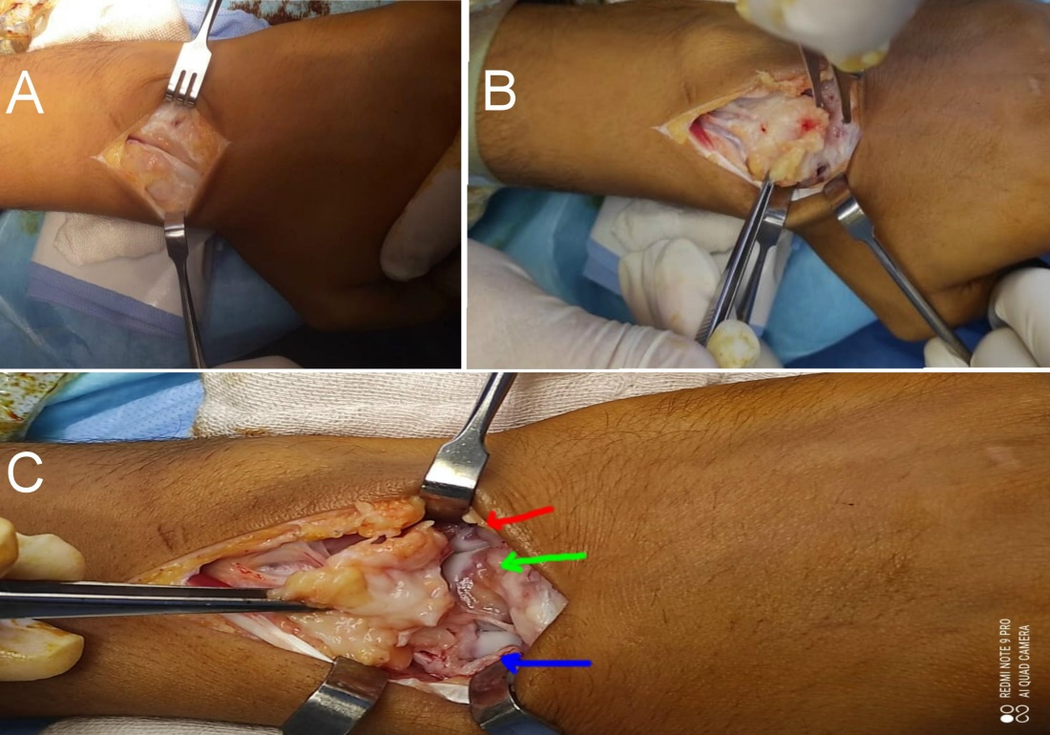
Figure 1: A) Dorsal approach and open 3rd compartment EPL tendon . B) Retraction of EPL and a proximal based flap. C) Elevation of flap , red arrow on Hamate base , Green arrow on capitate , Blue arrow on scaphoid and fracture site.
The proximal pole of scaphoid is removed with keeping the remaining scapho-lunate ligament freed off it and attached to the lunate , then the distal scaphoid proximal surface was prepared by curettage and osteotome till identify punctate bleeding while the tourniquet was deflated.[Fig 2]
Then the length , depth and width of the defect and the excised pole measured to detect the graft size will harvest .
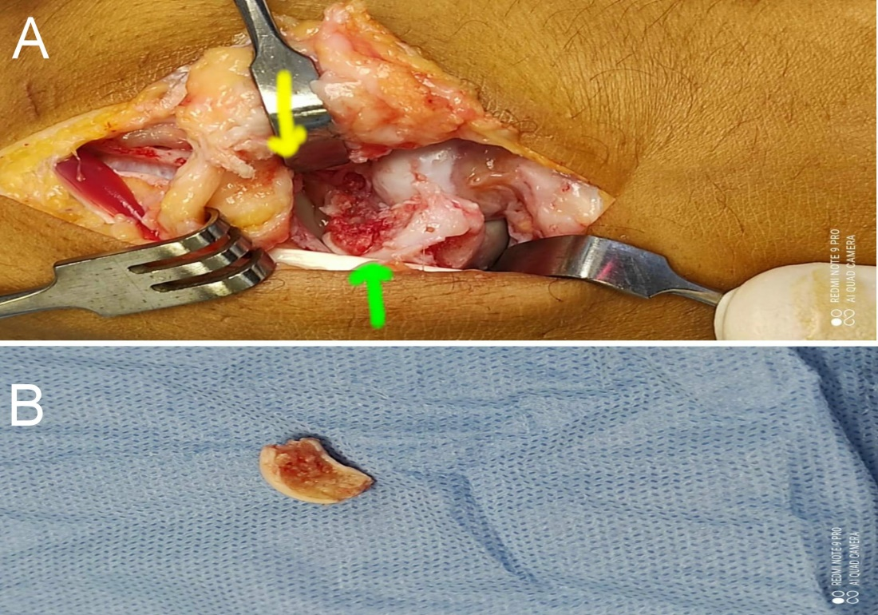
Figure 2: A) After excixion of proximal pole and keep scapholunate ligament attached to lunate [yellow arrow] ,and prepare the distal scaphoid till punctate bleeding [green arrow] . B) Proximal pole post excision show unhealthy bone and it’s diameters was taken .
From the same incision , the base of Hamate was marked as the same size as the defect and separated with a small osteotome keeping the volar Capito-hamate ligament (CH) attached to the graft and separate it from the capitate , at this step attention should be directed to take care of distal Triquetro-hamate ligament ( TH ) not to be injured to prevent future mid carpal instability , so if it was injured repair should be done via suture anchor . After harvesting the graft , size checks in comparison to excised scaphoid pole , then the graft was rotated 180 degrees before fixation to make the attached ligament of the Hamate base dorsal , to repair the detached scapho-lunate ligament . [Fig 3]
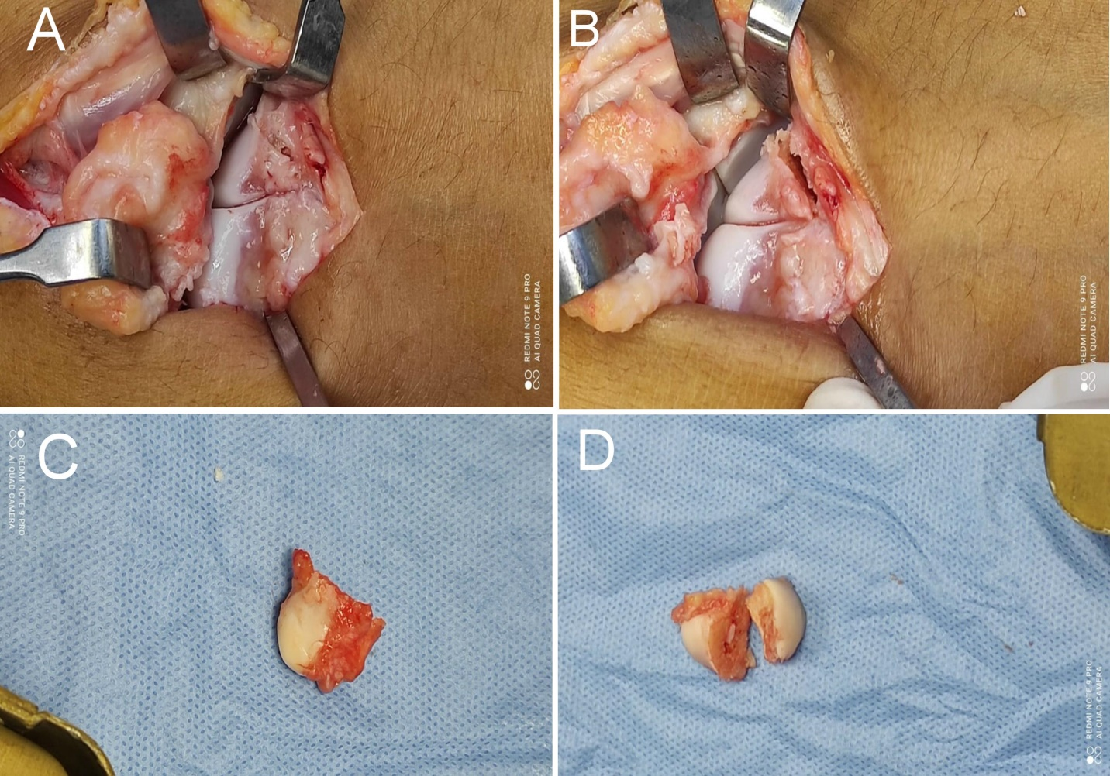
Figure 3: A) Mark base of Hamate to fit the defect size. B) Osteotomy done keeping the volar CH ligament intact . C) Harvested graft with attached volar CH ligament . D) Compare graft size and rotate it 180 degree.
The graft was fixed in its position via preliminary k-wire then after image intensifier check fixation is done with a headless screw through dorsal or volar entry according to surgeon preference .
Alignment of scapho-lunate interval and mid-carpal relation should be checked before scapho-lunate ligament repair , and Lunate reduced to a neutral position and stabilized with Capito-lunate wire . [Fig. 4]
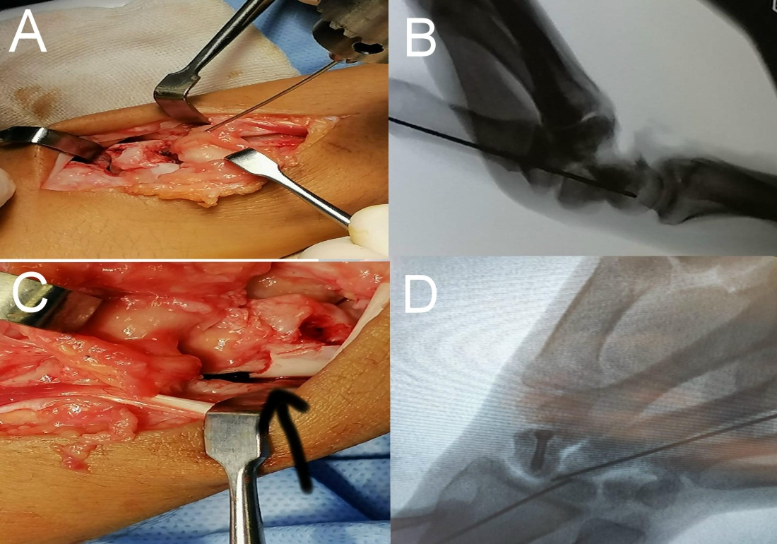
Figure 4: A) Reduction of graft and fixation by k-wire , B) Intraoperative lateral view . C) Fixation and compression of the graft via Herbert screw , black arrow show site of fracture compressed, D) Graft well positioned and reduction of lunate and fixation by k-wire through capitate.
Repair of the scapho-lunate ligament by suturing the remnant of Lunate attachment to Capito-hamate ligament on the graft that rotated and became dorsal , then dorsal capsulodesis used to augment the repair by suture anchor fixed in scaphoid . [Fig. 5]
During scaphoid pole excision if sufficient scapho-lunate ligament couldn’t be kept attached to lunate , a suture anchor fixed in lunate can be used to augment the repair . [Fig. 6].
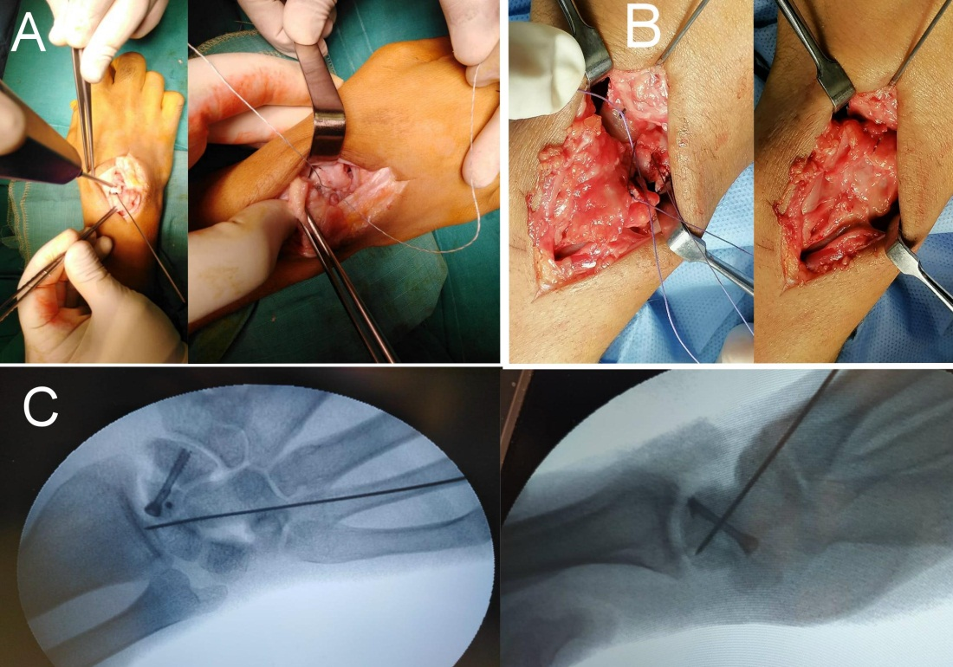
Figure 5: A) Suture anchor used to augment the scapho-lunate ligament repair , B) Dorsal capsulodesis to scaphoid to augment ligament repair , C) Intraoperative final image show proper graft and screw position , anchor , capito-lunate wire.
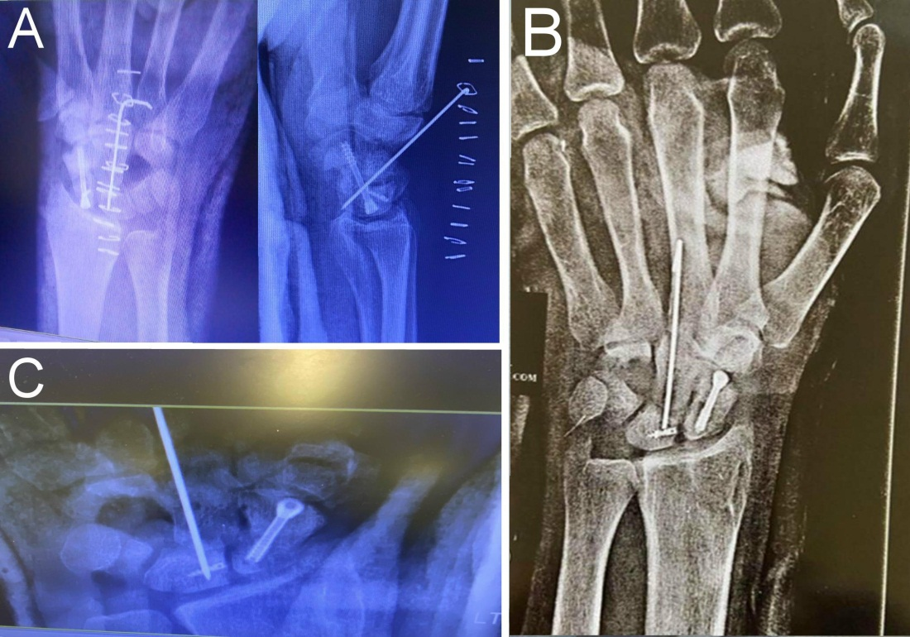
Figure 6: A) Post operative x ray of a case we used suture anchor in scaphoid , B & C) Post operative x rays of a cases we used suture anchors in lunate to augment scapho-lunate repair.
The capito-lunate wire was cut under the skin , then after skin closure, a below elbow thumb splint was done and changed with thumb spica with sutures removal 2 weeks post-operative , then follow up done every 2 weeks and C.T. scan done at 6-8 weeks to assess bony union by the presence of bridging trabecular bone more than 50% . When the union was achieved k-wire and cast were removed and physiotherapy is initiated .
Functional outcomes were assessed by VAS score for pain and Modified Mayo wrist score.
Statistical analysis:
Data were analyzed by the Statistical Package of Social Science (SPSS) software package for Windows (Standard version 16; SPSS Inc., USA). The normal data distribution was tested by Shapiro test. Qualitative data were described by relative frequency (number of occurrences) and percentages.
Association between categorical variables was tested using Chi-square test or its equivalent when the cell count less than 5. Continuous variables were presented by the arithmetic mean (for central tendency) and standard deviation (SD)

Results:
All fractures went on clinical and radiological union except for two cases where nonunion of the fractures and radio-scaphoid arthritis occur . The mean union period was 10.2 weeks (range 9-14 weeks) . [Fig. 7]
The mean follow up period was 11 months (9-14) , there was a significant improvement in VAS score than in preoperative state with a mean value of 2 ( range 0 – 5) , also there was a significant improvement in hand grip from 53.7 % preoperative to 89 % of the healthy side at final follow up ( range 80-95 % ) , according to Mayo wrist score ; 16 patients were excellent , 2 good and 2 poor results with mean 93.1(range 79-98). There was no significance according to the size of the graft harvested on the final results , size range (4-9 mm )( Table 1)
Table 1 : Demographics and results of the patients
 | Data | P value
Age (years)  Range  mean±sd | 19-42  29±2.5 | NS
Gender (n,%): Male  Female | 12  8 | NS
Size of the graft in mm | 4 – 9  6 ± 2 | NS
VAS score  Range mean±sd | 0-5  2±0.5 | p < 0.05
Grip strength  Range mean±sd | 80-95%  89±2.4% | p < 0.05
Union Rate  Range mean±sd | 9 – 14wks  10.2±0.5 wks | p < 0.05
Mayo score  Excellent  Good  Satisfactory  poor | 16  2  0  2  93.1(range 79-98) | p < 0.05

Three patients had attrition of finger extensor tendons due to capito-lunate wire that healed with wire removal. Two patients have nonunion and radio-scaphoid arthritis , one of them was treated with limited wrist fusion and the other refused this option and was satisfied with his results as his job was office worker.

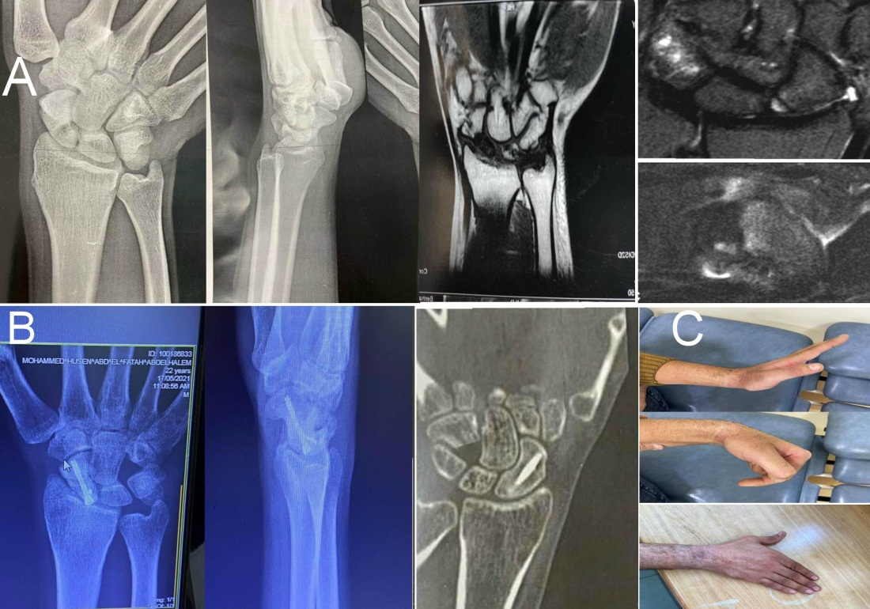
Figure 7: A) X rays and MRI of proximal pole AVN post fracture 8 months ago . B) 4 months post operative x rays and CT scan show complete union. C) 4 months functional range of motion
Discussion:
The scaphoid non-united fractures especially with AVN of the proximal pole represents a challenging problem . This is due to the lack of efficiency of bone healing associated with AVN . Not only fracture healing was the main problem but also fragmentation of the proximal pole and loss of cartilaginous cap and scapho-lunate ligament disruption . All these problems should be in mind when treating such problematic cases .
The management strategy was to achieve union and restore the scapholunate ligament with cartilage capped graft , with decreased graft donor site morbidity .
Free vascularized and pedicled grafts have been described in treating this problem [5,6] . Also medial femoral condyle vascularized bone graft was demonstrated [7] , iliac bone graft was a widely used method [8] another trial with an osteochondral graft from the rib was done [9,10,11] and finally proximal scaphoid allograft was used [12] . Most of these methods need longer time operation due to micro-vascular anastomosis or have graft donor site morbidity such as paraesthesias or numbness in the saphenous nerve distribution [13] . Lastly most of these grafts do not address the reconstruction of the scapho-lunate ligament [14] .
In our study we used the proximal Hamate to reconstruct the proximal pole of scaphoid by a non-vascularized auto graft have cartilaginous surfaces nearly similar to that of scaphoid , restore scapho-lunate ligament by capito-hamate ligament attached to the graft and also addresses the donor site morbidity issues by using the same operative approach without compromising carpal stability.
A study by S. Kakar et. al. [15] was done to quantify the similarity of the topology of the articulating surfaces of the hamate and scaphoid . They found that there were similarities between the 2 articular surfaces; 60% of the hamate autografts had over 90% surface correspondence to the scaphoid.
Wu et. al. [16] performed an anthropometric analysis of the scaphoid proximal pole to the proximal hamate on 29 cadaveric studies , their results were 70% similar .
Marion B. et. al. [17] used an experimental setup of the wrist stimulator on fresh-frozen mid-forearm cadaver specimens with a wrist simulator to move the wrist through a cyclical motion , to assess restoration of native wrist kinematics after reconstruction of proximal scaphoid by proximal hamate. They conclude that proximal hamate grafts restored scapho-lunate kinematics close to the intact state in both flexion- extension and radial-ulnar deviation.
Our study was held on 20 patients with non-united proximal pole scaphoid fractures with AVN of the proximal pole , all treated with excision of proximal pole scaphoid and reconstruct with proximal hamate autograft and repair scapho-lunate ligament , we achieved complete union in 18 patients with union period 10.2 weeks (range 9-14 weeks) ,while two patients couldn’t achieve union and this was mostly due to improper compression during fixation and immobilization post-operative , one of them treated with limited wrist fusion and other one refused this option. The graft size taken during this study ranged from 4 to 9 mm , and this didn’t affect the final outcomes and also had no effect on Triquatro-hamate articulation over the follow up period. The final Mayo score was 93.1(range 79-98).
Our results were comparable to other methods of treatment , a study done with non-vascularized cortico-cancellous iliac bone graft and Herbert screw fixation on 11 patients , with union rates 12 to 24 weeks , and Mayo score 91.4 points postoperatively [1].
Greg T. et. al. [18] treated 15 patients with palmar radiocarpal artery vascularized bone graft , all fractures united with mean 12 weeks , with mean period of immobilization 8.8 weeks.
A retrospective study done by Mark S. Morris et. al. [19] on patients treated with inter-compartmental supra-retinacular artery vascularized graft and compression screw fixation , with union rate 100% with mean period 12 weeks .
The results of our study were in line with a study done by Andrea H.W. Chan et. al. [14] with the same technique , their follow up was 3.5 years with Mayo wrist score was 90 .
Limitations of our study were the small number of patients , the lack of a control group and short follow up period . Larger scale studies are needed to assess long-term functional outcomes , with randomized control studies .
Conclusion :
The use of proximal hamate as an autograft to reconstruct the proximal osteocartilaginous surface of the scaphoid nonunited fractures with AVN of proximal pole is a promising technique. Take care of Triquetro-hamate ligament injury during graft harvesting . Prober graft size and Capito-Hamate ligament harvest are one of important steps to success the operation.
Declaration of Conflicting Interests:
The author(s) declared no potential conflicts of interest concerning the research, authorship, and/or publication of this article. ICMJE forms for all authors are available online.
Funding:
The author(s) received no financial support for the research, authorship, and/or publication of this article.
References:
- Hiroyuki Matsuki , Junichi Ishikawa , Norimasa Iwasaki , Shigeharu Uchiyama , Akio Minami and Hiroyuki Kato : Non-vascularized bone graft with Herbert-type screw fixation for proximal pole scaphoid nonunion. J Orthop Sci (2011) 16:749–755

- Joshua A. Gillis, Bassem T. Elhassan, and Sanjeev Kakar (2022) Hamate to Scaphoid Transfer for Non reconstructable Proximal Pole Scaphoid Fractures . WilliamB.Geissler : Wrist and Elbow Arthroscopy with Selected Open Procedures . Springer ; third edition ,chapter 44 : 555 – 559.

- Michael G. Fox1, Cree M. Gaskin ,A. Bobby Chhabra and Mark W. Anderson : Assessment of Scaphoid Viability With MRI: A Reassessment of Findings on Unenhanced MR Images. (2010) AJR; 195: W281–W286

- Cerezal L, Abascal F, Canga A, García-Valtuille R, Bustamante M, del Piñal F. Usefulness of gadolinium- enhanced MR imaging in the evaluation of the vascularity of scaphoid nonunions. AJR 2000; 174:141–149

- Zaidemberg C, Siebert JW, Angrigiani C. : A new vascularized bone graft for scaphoid nonunion. J Hand Surg Am 1991;16(3):474–8.

- Loukia K. Papatheodorou a , DimitriosV. Papadopoulos b , MicaelaM. Graber c , Dean G. Sotereanos : Dorsal capsular-based vascularized distal radius graft for proximal pole scaphoid nonunion with avascular necrosis. Injury 52 (2021) 3635–3639

- Ditsios K, Konstantinidis I and Agas K : Comparative meta-analysis on the various vascularized bone flaps used for the treatment of scaphoid nonunion. J Orthop Res 2017;35(5):1076–85.

- Roberto Diaz and James Chang (2015) : Scaphoid Nonunion Treated with Iliac Crest Structural Autograft. Jeffrey Yao : Scaphoid Fractures and Nonunions A Clinical Casebook . Springer ; chapter 10 : 109-121

- Marco Lanzetta : Scaphoid reconstruction by a free vascularized osteochondral graft from the rib: a case report . Microsurgery 2009;29(5):420-424

- Veitch S, Blake SM, David H. : Proximal scaphoid rib graft arthroplasty. J Bone Joint Surg Br 2007;89(2): 196–201.

- Yao J, Read B, Hentz VR.: The fragmented proximal pole scaphoid nonunion treated with rib autograft: case series and review of the literature. J Hand Surg Am 2013;38(11):2188–92.

- Carter PR, Malinin TI, Abbey PA, Sommerkamp TG. : The scaphoid allograft: a new operation for treatment of the very proximal scaphoid nonunion or for the necrotic, fragmented scaphoid proximal pole. J Hand Surg Am. 1989;14(1):1–12.

- Mehio G, Morsy M, Cayci C: Donor site morbidity and functional status following medial femoral condyle flap harvest. Plast Reconstr Surg 2018;142(5):734e–41e.

- Andrea H.W. Chan , Bassem T. Elhassan and Nina Suh : The Use of the Proximal Hamate as an Autograft for Proximal Pole Scaphoid Fractures, Clinical Outcomes and Biomechanical Implications . Hand Clin 35 (2019) 287–294

- Sanjeev Kakar, Ryan M. Greene, Bassem T. Elhassan, and David R. Holmes: Topographical Analysis of the Hamate for Proximal Pole Scaphoid Nonunion Reconstruction. J Hand Surg Am. Vol. 45, 2020 ; 69.e1- 69.e7

- Wu K, Padmore C, Lalone E, Suh N.: An anthropometric assessment of the proximal hamate autograft for scaphoid proximal pole reconstruction. J Hand Surg Am. 2019;44(1):60.e1-e60.e8.

- Marion Burnier, Joseph A. Gil , Alexander Hooke, Bassem Elhassan, and Sanjeev Kakar : Does Proximal Hamate Graft for Proximal Scaphoid Reconstruction Restore Native Wrist Kinematics?. HAND, 2022 , ﻿1– 8 . https://doi.org/10.1177/155894472110635

- T. Greg Sommerkamp, Hill Hastings and Jeffrey A. Greenberg: Palmar Radiocarpal Artery Vascularized Bone Graft for the Unstable Humpbacked Scaphoid Nonunion With an Avascular Proximal Pole. J Hand Surg Am. Vol. 45, 2020 ; 298 – 309.

